Trans-related books for Teens
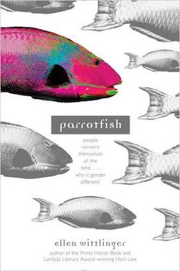
Parrotfish (2014)
Author: Ellen Wittlinger For Ages: 12yo+ Type: Novel
Summary: Angela Katz-McNair never felt quite right as a girl. So she cuts her hair short, purchases some men’s clothes and chooses a new name: Grady. While coming out as transgender feels right to Grady, he isn’t prepared for the reactions of his friends and family. Fortunately he finds some kindred spirits (one of whom teaches him there’s a precedent for transgenderism in the natural world).
Praise: “Grady eventually decides that he will always straddle the 50 yard line of gender, and the book should help teens be comfortable with their own place on that football field.” —School Library Journal
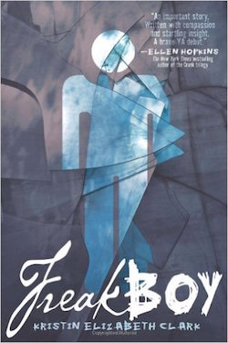
Freakboy (2013)
Author: Kristin Elizabeth Clark For Ages: 12yo+ Type: Novel
Summary: Brendan Chase is a star wrestler, a video game aficionado and a loving boyfriend to his seemingly perfect match, Vanessa. But on the inside, Brendan struggles to understand why his body feels so wrong — why he sometimes fantasizes having long hair, soft skin and gentle curves. The novel folds 3 narratives with 3 different perspectives presented in 3 different fonts into one cohesive story written in verse. Praise: “*This gutsy, tripartite poem explores a wider variety of identities — cis-, trans-, genderqueer — than a simple transgender storyline, making it stand out.” —Kirkus Review, starred review
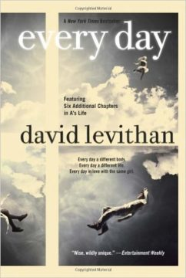
Every Day (2013)
Author: David Levithan For Ages: 12yo+ Type: Novel
Summary: A love story written by the author of Nick & Nora’s Infinite Playlist about A, a teen who wakes up every morning in a different body, living a different life.
Praise: “Amazon Best Books of the Month, September 2012: Every Day is technically for young adults, but the premise of this unusual book goes much deeper. It asks a question that will resonate with the young and old alike: Can you truly love someone regardless of what they look like on the outside?”
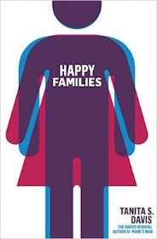
Happy Families (2013)
Author: Tanita S. Davis For Ages: 12yo+ Type: Novel
Summary: The life of teen twins is turned upside down when their father starts living as a female.
Praise: “The story’s focus on an African-American family makes it particularly notable in LGBTQ-themed teen literature. Warmly drawn; a valuable conversation-starter for families like Ysabel and Justin’s.” —Kirkus Review
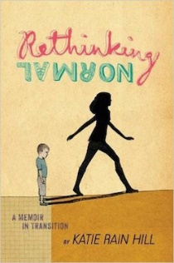
Rethinking Normal: A Memoir in Transition (2015)
Author: Katie Rain Hill For Ages: 13yo+ Type: Memoir
Summary: 19-year-old Katie Rain Hill shares her personal journey of undergoing gender reassignment. The book now includes a reading group guide.
Praise: “Will both educate cisgender readers and strike sparks of recognition in those questioning their own gender identities.” —Kirkus Reviews
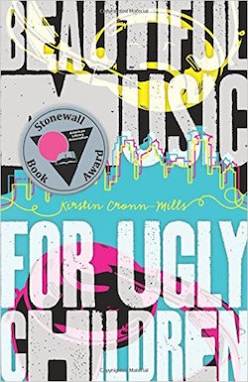
Beautiful Music for Ugly Children (2012)
Author: Kristin Cronn-Mills For Ages: 13yo+ Type: Novel
Summary: “This is Beautiful Music for Ugly Children, on community radio 90.3, KZUK. I’m Gabe. Welcome to my show....I’m like a record. Elizabeth is my A side, the song everybody knows, and Gabe is my B side―not heard as often, but just as good. It’s time to let my B side play.”
Praise:Winner of the 2014 Stonewall Book Award for Children’s and Young Adult Literature
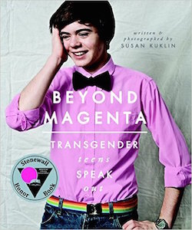
Beyond Magenta: Transgender Teens Speak Out (2015)
Author: Susan Kuklin For Ages: 13yo+ Type: Nonfiction profiles
Summary: Having met and interviewed six transgender or gender-neutral young adults, Kuklin presents them here before, during and after their personal acknowledgment of gender preference via portraits, family photographs and candid images.
Praise: A 2015 Stonewall Honor Book (also on the list of most challenged books of 2015)
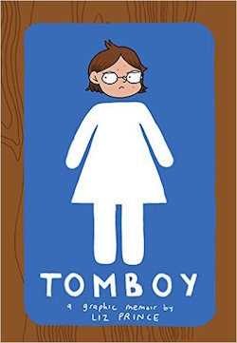
Tomboy: A Graphic Memoir (2014)
Author: Liz Prince For Ages: 14yo+ Type: Graphic novel
Summary: A graphic novel about refusing restrictive gender “norms” (and even sometimes inadvertently embracing gender stereotypes). Life lesson: there’s no one right way to be a girl. Praise: Kirkus Reviews Best Books of 2014 list, Texas Library Association (TLA) Maverick Graphic Novels List 2015, YALSA Great Graphic Novels for Teens 2015 nomination, Amelia Bloomer Project 2015 nomination, YALSA Quick Picks 2015 nomination, Cybils Awards 2014 nomination, Teen Choice Book of the Year Awards nomination, Broken Frontier Awards nomination
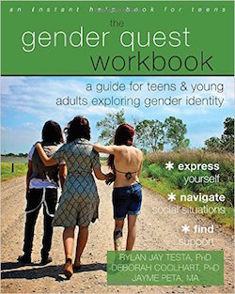
The Gender Quest Workbook (2015)
Author: Multiple authors For Ages: 14yo+ Type: Workbook
Summary: A comprehensive workbook that incorporates skills, exercises and activities from evidence-based therapies — such as cognitive behavioral therapy (CBT) — to help transgender and gender nonconforming (TGNC) teens explore and navigate their gender identity and expression at home, in school and with peers.
Praise: “This workbook is an important resource for the transgender community. I wish I’d had something like it when I was coming out to myself.” — Greta Gustava Martela, cofounder and executive director of Trans Lifeline, the first national crisis line for transgender people
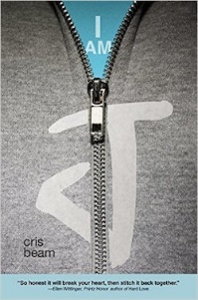
I Am J (2015)
Author: Cris Beam For Ages: 14yo+ Type: Novel
Summary: Sick of hiding the body that’s betraying him under baggy clothes, J runs away, begins attending a school for gay and transgender teens and ultimately decides to take testosterone, all while navigating family, friendships and young love.
Praise: An ALA Best Fiction for Young Adults Title, a California State Recommended Literature List Pick, an Amazon Best Book of the Month Pick, a Kirkus Reviews Best YA Book of the Year
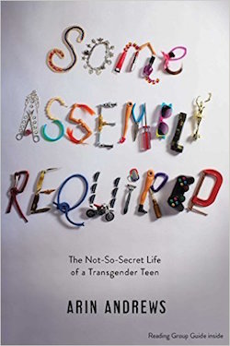
Some Assembly Required: The Not-So Secret Life of Transgender Teen(2015)
Author: Arin Andrews For Ages: 14yo+ Type: Memoir
Summary: 17-year-old Arin Andrews Arin reveals the challenges he faced as a boy in a girl’s body, the humiliation and anger he felt after getting kicked out of his private school and all the changes — both mental and physical — he experienced once his transition began. Now with a reading group guide and an all-new afterword from the author.
Praise: “This is a brave book that handles complicated and sensitive topics honestly and, at times, with humor.” —Publishers Weekly
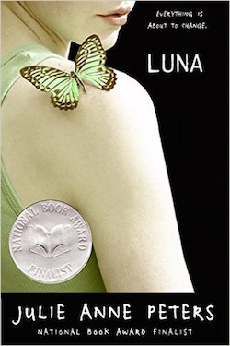
Luna (2006)
Author: Julie Anne Peters For Ages: 14yo+ Type: Novel
Summary: Regan helps her brother Liam with his secret, supplying clothes and makeup and cover — that is, until her sibling decides to go public as Luna, which threatens Regan’s own social standing.
Praise: National Book Award Finalist, an ALA Best Book for Young Adults, a Stonewall Honor Book, a Lambda Literary Award Finalist, a Book Sense Summer Reading Book for Teens
Almost Perfect (2010)
Author: Brian Katcher For Ages: 14yo+ Type: Novel
Summary: Boy kisses girl, girl admits she was born a boy, boy dumps girl, boy grows to accept girl for who she truly is.
Praise: Winner of the Stonewall Children’s & Young Adult Literature Award
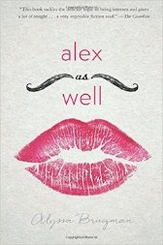
Alex As Well (2016)
Author: Alyssa Brugman For Ages: 15yo+ Type: Novel
Summary: An intersex kid forges a path between two genders to find their true self.
Praise: “Readers of authors such as John Green will devour this novel.” —Junior Bookseller & Publisher

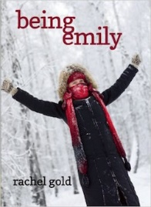
Being Emily (2012)
Author: Rachel Gold For Ages: YA Type: Novel
Summary: When Christopher tries to be Emily, her parents don’t understand, her therapist insists Christopher is normal and Emily is sick and her girlfriend lectures her about how God doesn’t make that kind of mistake. But there’s still hope! Praise: Winner 2013 Golden Crown Literary Award in Dramatic / General Fiction, Winner 2013 Moonbeam Children’s Book Award in Young Adult Fiction (Mature Issues), Finalist 2013 Lambda Literary Award
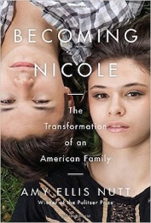
Becoming Nicole: The Transformation of an American Family (2015)
Author: Amy Ellis Nutt For Ages: Adult nonfiction (but appropriate for older teens) Summary: With access to personal diaries, home videos, clinical journals, legal documents and medical records, the author spent almost four years with this traditional family of adopted twin boys, one of whom transitions from Wyatt to Nicole. Praise: New York Times Bestseller, a New York Times Notable Book, named one of the Ten Best Books of the Year by People and one of the Best Books of the Year by Men’s Journal, a Stonewall Honor Book in Nonfiction and a Finalist for the Lambda Literary Award for Transgender Nonfiction

