USING THE AIM PORTAL FOR STUDENTS

Overview of the AIM Student Portal
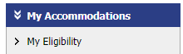
Once your application has been approved, you’ll meet with an Accommodations Coordinator about your accommodations and you’ll be able to access the Student Portal. You can view your accommodations via the menu on the left under My Accommodations, by selecting My Eligibility.

Requesting Faculty Notification Letters
The AIM system syncs with your course selections, and every semester you’ll use it to send Faculty Notification Letters to the instructors of courses you for which you intend to use accommodations.
- Log in to the Student Portal.
- If relevant, you’ll be directed to read and sign eForms related to alternative format texts, smart pens, and alternative testing. Complete these forms.
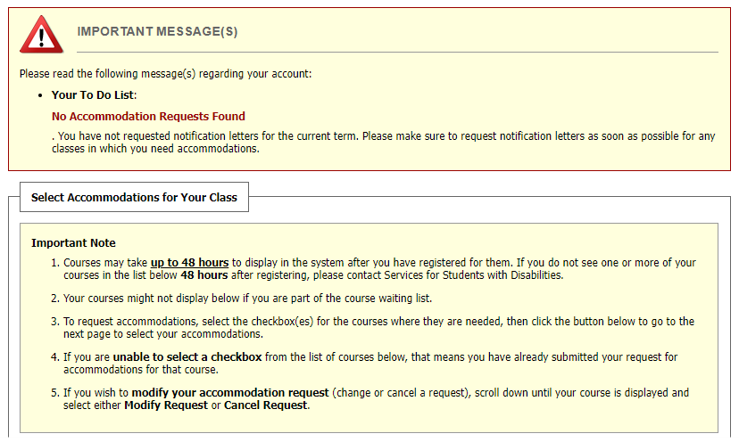
- This will take you to your Dashboard/Overview.
- Scroll down to the Select Accommodations for Your Class section and complete Step 1: Select Class(es).
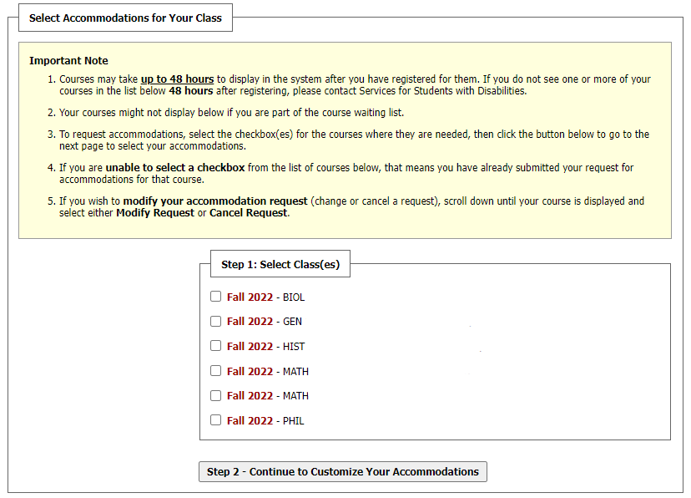
- Note: If you have recently added a class, you may need to wait up to 48 hours for the class to display.
- Scroll down and click Step 2: Continue to Customize Accommodations.
- On the next page you’ll see Select Accommodation(s) for Each Class, review each class and select which specific accommodations you require for each course.
- Scroll to the bottom of the pages after reviewing each class and click “Submit Your Accommodation Requests.
- FNLs are sent via email through the system to instructors and you receive a copy.

How to submit an Exam Request for the Test Center if you have testing accommodations
When notifying instructors of accommodations with Faculty Notification Letters, instructors are sent a link to fill out a form in AIM called a Testing Agreement, through which instructors outline their exam materials and parameters for the semester. After they fill that out for any student in their class who sends them an FNL, you can schedule exams.
Note: Please schedule your exams two business days in advance for Test Center scheduling purposes. Consider meeting with your instructor to discuss whether they’d like you to schedule all your exams in advance.
The Test Center is located on the fifth floor of McIntyre Library, room 5029.

- Log in to the Student Portal.
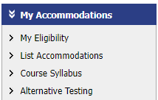
- On the left side menu under My Accommodations, select Alternative Testing.

- From the Select Class dropdown menu, select the specific course
- Click Schedule an Exam.
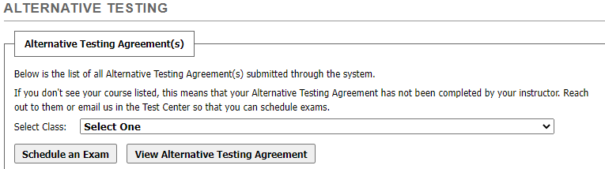
- Select the exam request type (quiz, exam three, final, make-up test, etc., it will be based on what your instructor has provided) from the dropdown menu.
- Clicking Exam Schedule Availability will bring up the general times you may schedule an exam, Monday through Friday, 8:15 am to 4:00 pm, giving notice of at least two business days. You don’t need to interact with this table.
- Enter the date and time for your exam.
  - Note: The duration (standard time) will be provided and verified in the Instructor’s Testing Agreement. There is no need to fill this out.
- Inside the Services Requested box are your accommodations. Click the boxes next to the accommodations you wish to use for the exam.
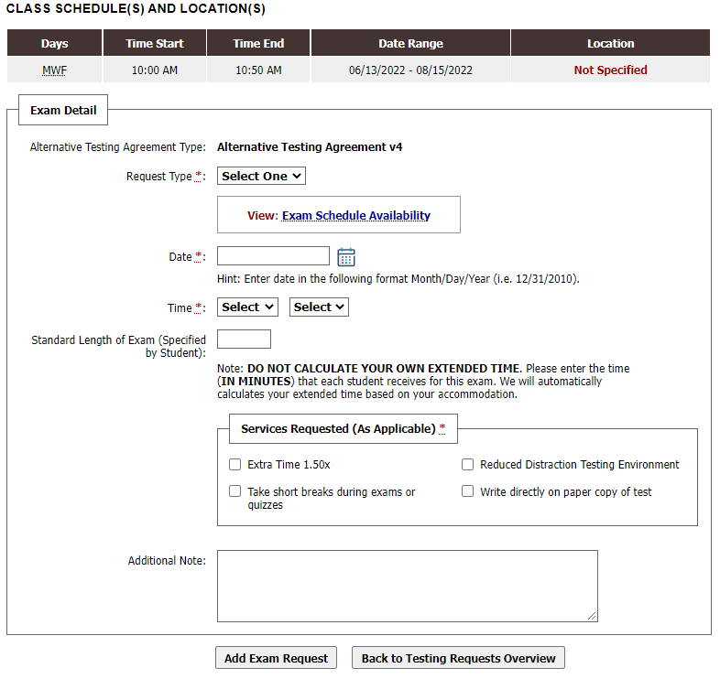
- Click Add Exam Request to submit exam scheduling request for review.
- You’ll receive an email that you’ve scheduled your exam and your instructor will receive an email notification as well.
- Test Center staff will look over the details and approve the request and you’ll receive a final confirmation email, or a request to reschedule, etc., if your instructor disputes the details of the exam. If you need to reschedule and the time is known, you’ll receive an email with a link to automatically confirm the new time.

How to Modify or Cancel an Exam Request
- Log in to the Student Portal.
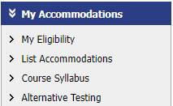
- Click Alternative Testing in the My Accommodations menu bar on the left side of the screen.

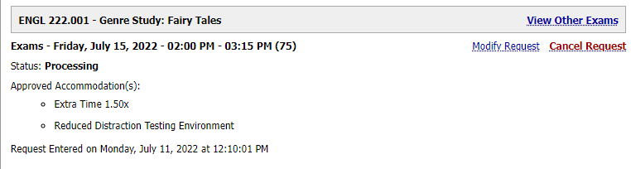
- Find the specific exam request you need to modify or cancel and click Modify Request or Cancel Request and then update any of the Exam Detail information.

How to See Your Upcoming Exams
- Log in to the Student Portal and click on Alternative Testing under the My Accommodations menu on the left. All exams you’ve scheduled, and their approval status, will be listed.

How to Request Alternative Format Texts
- Log in to the Student Portal.
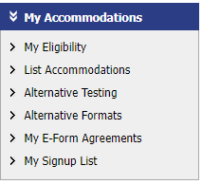
- Click Alternative Formats in the My Accommodations tab on the left side of the screen.

- In the main window, scroll to Request Alternative Formats for [Current Semester]
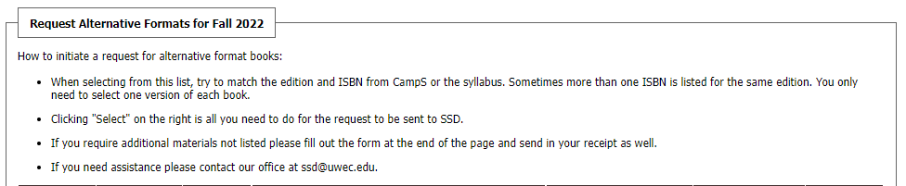
- Follow the instructions:

- Select your books according to edition and ISBN, if possible. You only need to select one version of each book.
- That’s it! See #9.
- If your book isn’t listed, scroll down to Additional Book or Reading Materials and type in as much information as possible.
- Click Submit Request.
- After your request is processed, you will receive an email with a link to download your books from OneDrive.

